Kanchan Singh

B.Tech, Computer Science and Engineering Email - [kanchansingh21512@gmail.com](mailto:kanchansingh21512@gmail.com) Contact no - 6370552982

**Career Objective :**

To continuously enhance my knowledge and technical skills by getting involved in challenging work environment and utilize them for personal and organizational growth to the best of my ability.

**Academic Qualifications :**

|  |  |  |  |  |
| --- | --- | --- | --- | --- |
| Exam/Degree | Name of Institute | University/Board | Year of passing | Percentage/CGPA |
| B.Tech.(CSE) | Silicon Institute of  Technology, Sambalpur | BPUT | 2022 | 9.25(CGPA) upto  5th semester |
| 12th (Science) | St. Arnold School, Rourkela | CBSE | 2017 | 78% |
| 10TH | St. Arnold School, Rourkela | CBSE | 2015 | 85% |

**Technical Skills :**

* Programming C, Core Java and Python
* Database D.B.M.S
* Web Server HTML, CSS, Javascript and PHP

**Academic Actvities :**

* Member, Literary Club 2019 - 2020
* Member, Silicon Scholar Club 2020 – present
* Member, Cultural Club 2019 - present

**Achievements :**

Academic performer

# Internship/Project :

* Organization -Milk Island

22nd May 2021- Present

3- months Internship program on Web Development

# Personal Profile :

* Father’s Name Ramashish Singh
* Mother’s Name Shila Singh
* Date of Birth 05 /12/1999
* Marital Status Unmarried
* Languages Known English and Hindi
* Nationality Indian
* Address BL/19, Basanti Colony

Rourkela, Odisha

**Declaration :** I do hereby declare that the information furnished above is true to best of my knowledge.

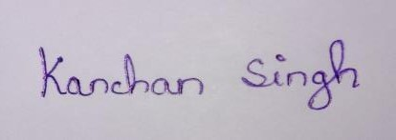

**Date :** 06/02/2021 **Signature :**

**Place:** Rourkela